Android Final Project:

MeetMe

Guy Arditi, 300317765

Artum Zolotushko 311674782

Application’s purpose

The application will offer the user an easy way to arrange activities with friends based on their schedule.  
Simple things like going out for lunch, synchronizing sport and other activities without having to scan all your friends schedules manually.

It will also help notify your friends of your activities (at least those you’d like to have people join), and categorize them for easier filtering.

Main functionalities

The application will offer a variety of ways to synchronize your schedule with your friends.  
MeetMe will import your friends from facebook.

1. Adding and tagging activities you would like to do with others, and adding them to your google schedule.
2. Searching for others to do an activity with, either by a specific activity type, a time frame, or an area.
3. Viewing the activities of a friend, to make it easier to synch your activities.
4. Managing activity participants.
5. Searching for friends nearby with similar interests and offer them to join your activities.
6. Giving feedback on activities, for easier prioritizing in the future.

User Stories

1. Bob is looking to play Tennis today.  
   He opens MeetMe and schedules his Tennis session for 15-17.

An hour prior to his Session, he receives a notification that someone has requested to join his event.

Bob accepts the new participants, but needing more, he decides to search the area for more of his Tennis buddies.  
MeetMe finds 2 more people in the area, and Bob sends them an invite.

1. Alice wants to go out for the night but doesn’t know what to do.  
   She asks MeetMe to show her all of her friends activities for the evening.  
   After getting too many results, she decides to search by her closest friends.  
   She opens her best friend’s schedule, and see what Bar she’s going to tonight.  
   Alice sends a join requests, and 10 minutes later receives a confirmation from her friend.

Application Pre-Requisites

The application requires the following permissions:

1. Facebook contacts list
2. Access to google calendar
3. Internet connectivity
4. GPS

Flow description

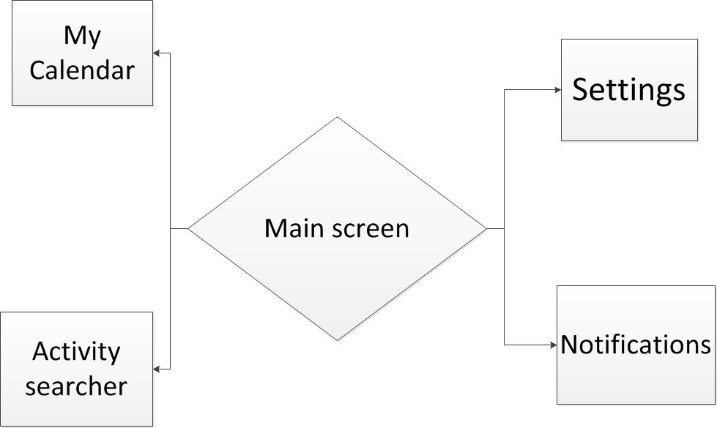Below are the basic connection between the activities of our program.